HOLT TOWN COUNCIL

MEETING OF THE SPOUT HILLS COMMITTEE ON MONDAY 26TH
SEPTEMBER 2016 at 4.00 p.m. Holt Community Centre

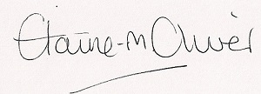
Elaine Oliver
Town Clerk

19th Sept

AGENDA

- ELECTION OF CHAIRMAN

- ELECTION OF VICE-CHAIRMAN

- APOLOGIES

- DECLARATIONS OF INTEREST

5. AGREE THE MINUTES OF THE MEETING HELD ON 19th APRIL 2016

6. CLOSE THE MEETING FOR PUBLIC PARTICIPATION

Public Participation

7. PROGRAMME OF WORKS (If applicable)

- CONSIDER ANY CORRESPONDENCE RECEIVED

- CONSIDER DATE OF NEXT MEETING

